

[http://www.sunrom.com](http://www.sunrom.com/)

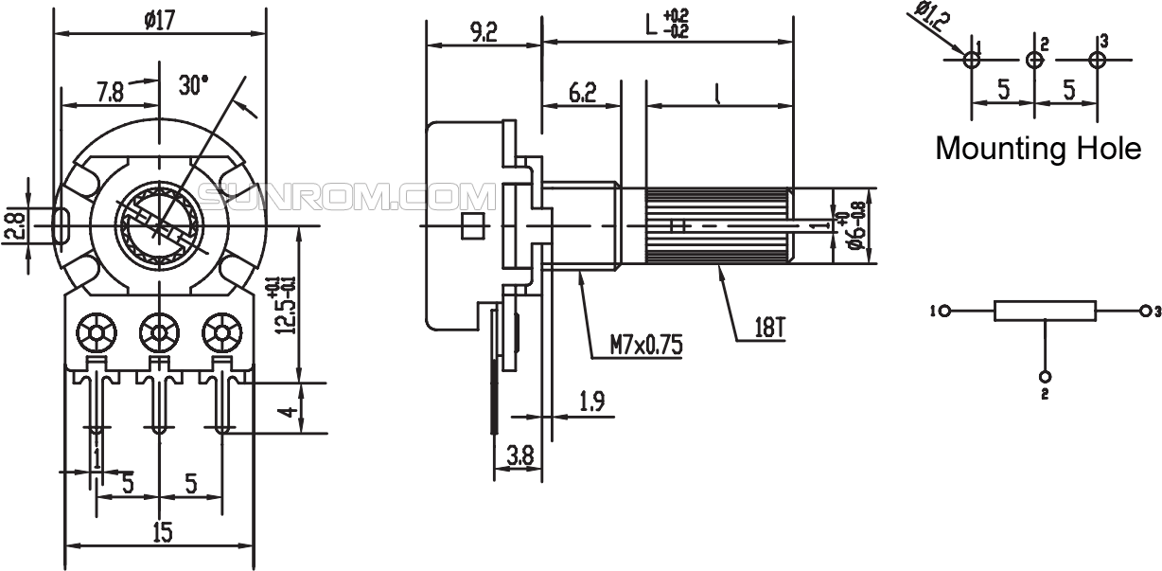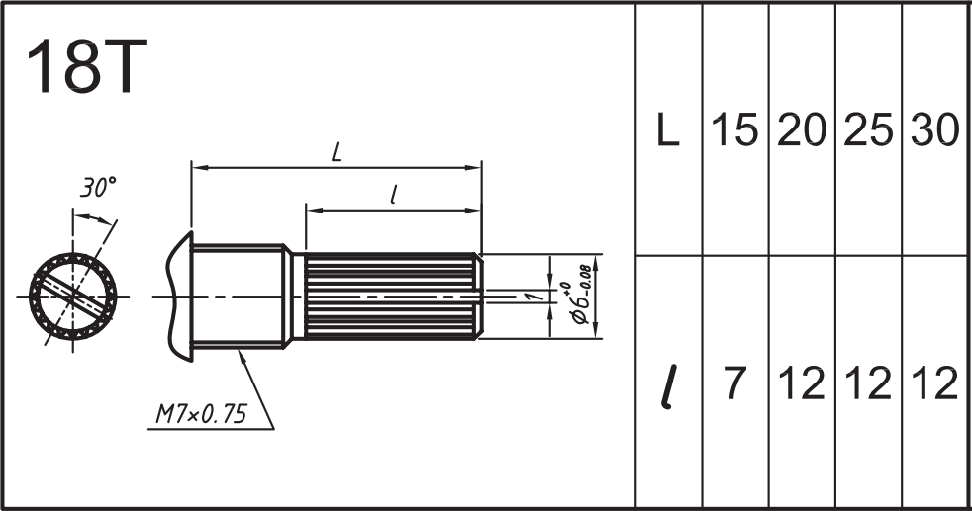

**ROTARY POTENTIOMETER (VOLUME CONTROL)**

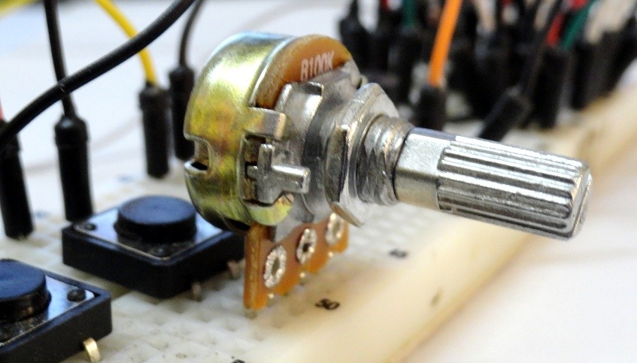

Variable Resister, Potentiometer, Linear, B Type potentiometer, 10K Linear Volume Control aka Potentiometer, It's a B Type Volume Control which implies linear variation while A Type is Logarithmic variation. This POT can be used in Audio Applications like Tone Control, Volume Control and variety of other Experimentation activities. It can be hooked directly onto breadboard.

**DIMENSIONS**

SHAFT DIMENSIONS

# SPECIFICATIONS

## MECHANICAL SPECIFICATIONS

* Total rotation angle: 300°±5°
* Rotation torque: 2 ~ 20mN.m (20 ~ 200gf.cm)
* Shaft stop strength: 6Kgf.cm
* Push pull strength: 60N
* Rotary life: 10000 cycles

## ELECTRICAL SPECIFICATIONS

* Resistance taper: A, B, C
* Resistance tolerance: ± 20%
* Rotational noise: K ≤ 47 m V
* Tracking error: 0 ~-40dB 3 dB
* Rated wattage: Curve B: 0.125W; Other than B: 0.063 W
* Max, operating voltage: Curve B: 200 V; Other than B: 150 V
* Dielectric: AC500V, 1 minute
* Insulation resistance: More than 100MΩ at DC500V

# ORDERING DETAILS

|  |  |  |
| --- | --- | --- |
| **Sunrom Part#** | **Value** | **L=Length Ordering Page** |
| **5169** | 10K | 15mm <http://www.sunrom.com/m/5169> |